**Strategic Market Analysis for Target Light Retail Expansion**

This report outlines a data-driven approach to identify the top ten markets for the launch of a new retail startup, Target Light, that will compete with stores like Target and Walmart. Using Walmart sales data from 2011 to 2012, I will determine the ten best locations to open these stores that will ideally be geared towards middle income to high income households. I utilized a variety of datasets, ranging from demographic insights in the Designated Market Area data and Metropolitan Statistical files to historical sales data, to inform my analytical strategy. The historical sales data provides information from forty-five competitive stores across the country. It contains data on the weekly sales per each department, dates, and whether the week had a holiday in it. The features dataset allows us to see certain variables that might be related with consumer spendings habits like temperature, fuel price, CPI, and unemployment. The dataset includes a holiday variable that consists of Labor Day, Super Bowl, Thanksgiving, and Christmas sales information. All this information is very important to consider when choosing where throughout the country the new startup will be launched.

The first step in the analysis process was to develop a strategic framework aimed at identifying the ten best markets to launch new retail startups that compete against superstore competitors like Target and Walmart. The plan consists of first opening the datasets and exploring the different variables in them. The datasets were thoroughly examined to understand the variables involved. Data cleaning and preparation was the next step, which ensured that the information was ready for analysis. The next crucial step was joining the different datasets. The DMA file was combined with all the MSA files because they shared a similar DMA column. The *sales data-set.csv* was joined with the *stores data-set-withDMA.xlsx* because they both had a common store number column. With the combined data in place, focus moved to deciding the dataset features that had the biggest impact on a store’s success. Afterwards, visualizations were created to see what DMAs were the most attractive for the startups. The top ten markets for the retail startup were then decided. The last step in the process was to write this detailed launch recommendation which consists of the visualizations and information found.

This section outlines the methodology and analysis performed. It focuses on several factors such as the number of competitor stores by DMA, DMA average weekly sales, populations, median household incomes, household counts, holiday sales, and economic health. These factors were carefully evaluated to find out the viability of markets for the new retail startups.

*Figure 1: Number of Competitor Stores by DMA*

The bar graph in Figure 1 provides a visual representation of the number of competitor stores across the various Designated Market Areas. Los Angeles has the highest number, which indicates a saturated market. Markets like Charlotte, Kansas City, Philadelphia, Tampa St. Pete, and Orlando have fewer established competitor stores, which may lead to opportunities for new entrants. These markets with a smaller number of competitors can allow Target Light to establish a stronger market presence with lower barriers to entry. Additional factors within these DMAs will be analyzed to assess the viability of these less saturated markets.

*Figure 2: Top 25 DMAs by Population 18+* *Figure 3: DMA Stores Per Capita*

Figure 2 shows the different population sizes, in millions, of the different DMAs for individuals ages 18 and over. The DMAs with the largest population were New York, with a population of 16.8 million, Los Angeles with 14 million and Chicago with 7.4 million. To gain further insight into these DMAs, an analysis of the stores’ per capita values was executed, and the results are displayed in Figure 3. This value represents the ratio of the number of stores to each DMA’s population size and helps identify areas where there is less competition, therefore more opportunity for new stores. Philadelphia, Chicago, Los Angeles, Houston, and Atlanta were the DMAs with the lowest values. DMAs like San Diego, Charlotte, Denver, and Salt Lake City also performed well when it came to this metric.

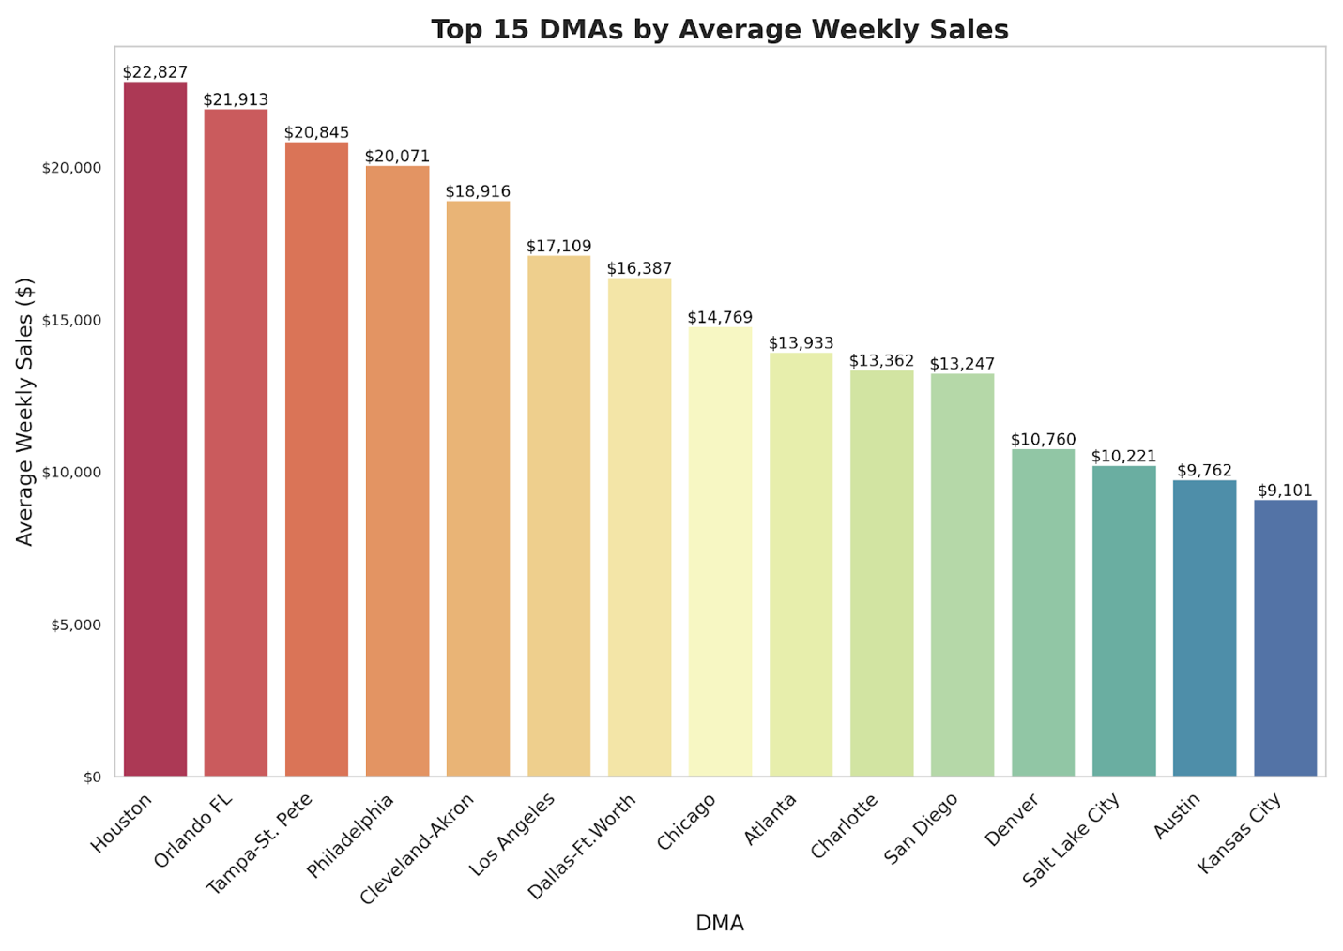

*Figure 4: The Top 15 DMAs by Average Weekly Sales*

Figure 4 provides a clear representation of how the DMAs compare to each other in terms of average weekly sales. Houston has the highest average weekly sales coming in at 22,827 dollars a week, followed by Orlando-Daytona Beach-Melbourne FL with an average of 21,913 dollars a week. Tampa St. Pete, Philadelphia, Cleveland-Akron, and Los Angeles also showed strong weekly average sales numbers. The markets with higher sales numbers indicate more potential business in those areas which is important to consider when planning the retail expansion strategy. Kansas City, Austin and Salt Lake City had the lowest sales number, meaning there may not be as many consumers in those DMAs.

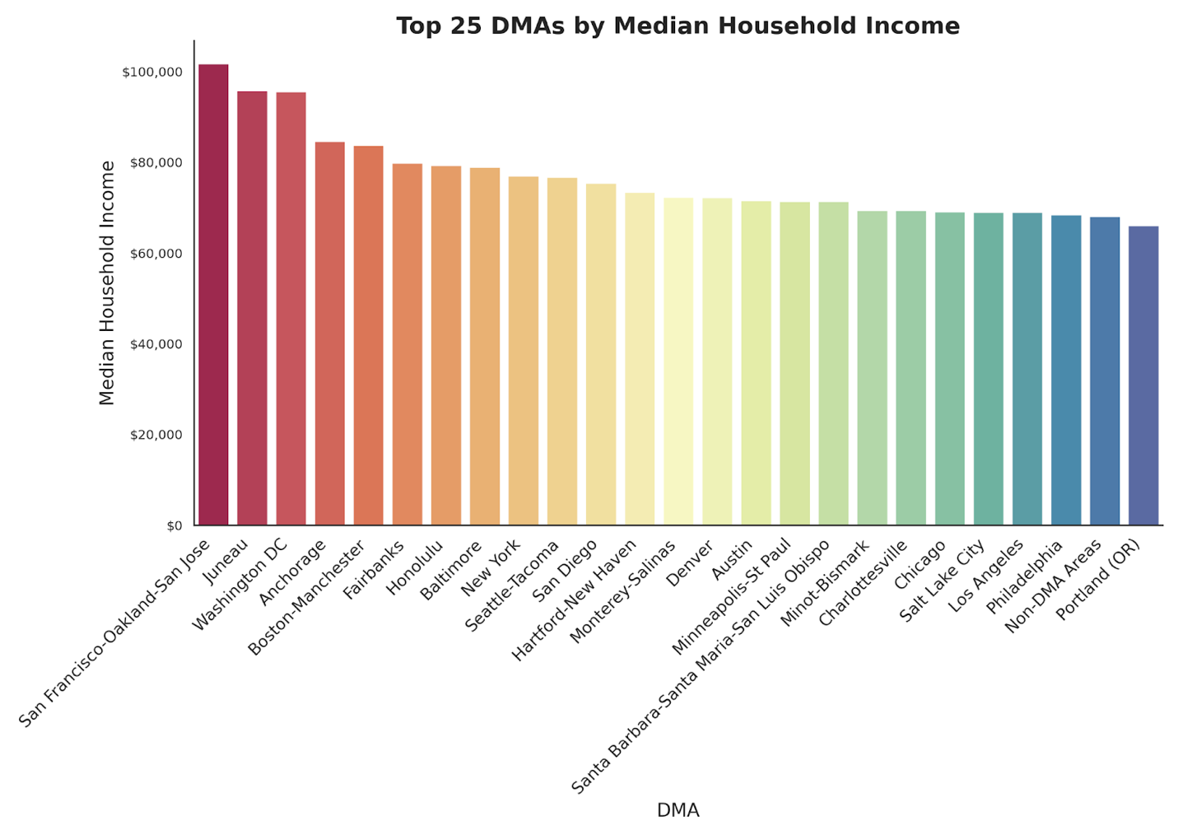

*Figure 5: The Top 25 DMAs by Median Household Income*

Another factor to consider for determining the ten best markets to compete effectively against competitors is median household income. Target Light's main target consumers are middle income to high income households. Figure 5 shows that San Francisco-Oakland-San Jose, Juneau, and Washington DC have the highest median household income. These markets have more money available to spend, therefore it would be smart to open our stores in them. Some of the DMAs that we have seen in previous figures that have high median household incomes are New York, San Diego, Denver, Austin, Chicago, Salt Lake City, Los Angeles, and Philadelphia. Given that we have more data on these DMAs, we are going to consider them more than the top ones like San Francisco.

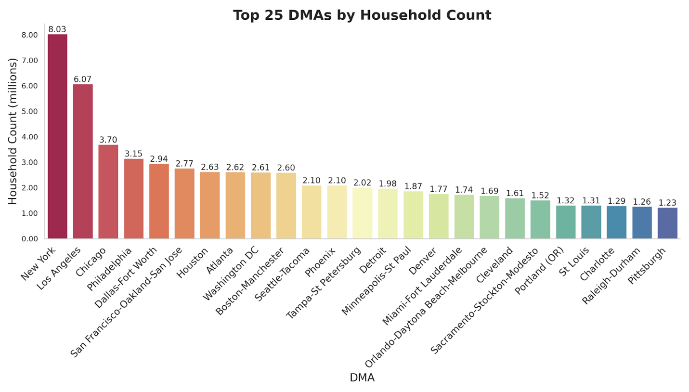

*Figure 6: The Top 25 DMAs by Household Count*

Figure 6 shows the top 25 DMAs by household count. Results showed that New York had the highest total by a significant margin, with approximately 8.03 households. Los Angeles came in second having around 6.07 households and Chicago had 3.70 million. Household counts are a good indicator for understanding market sizes. They can be targeted aggressively because they offer great visibility and a larger customer base. Figure 6 contains a mix of large metropolitan areas and smaller significant areas like Charlotte and Pittsburgh. All these DMAs in the figure would be solid market entry locations for Target Light because they contain a great number of households and suggest that there are large consumer bases in those areas.

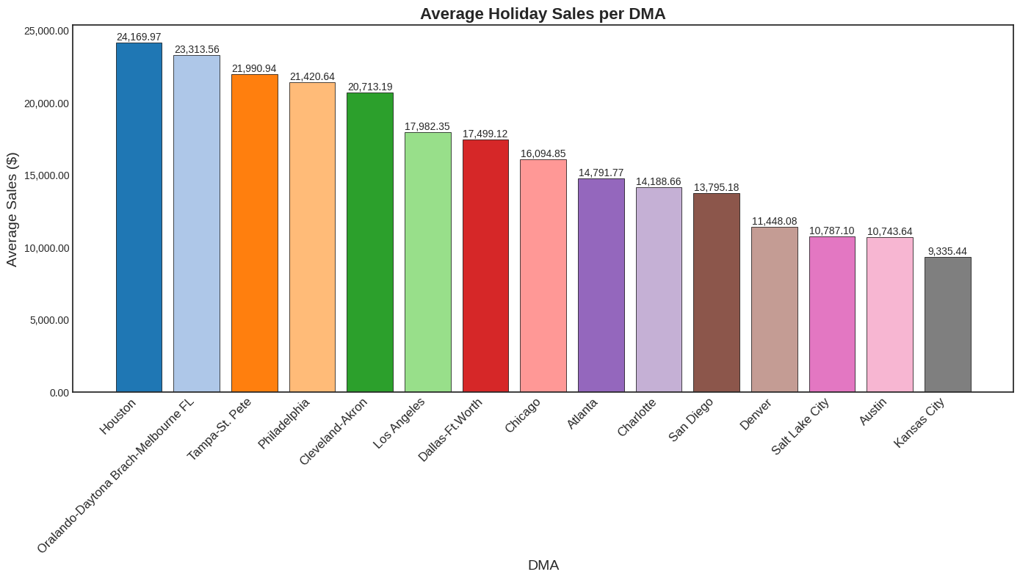

*Figure 7: The Average Holiday Sales per DMA*

For stores like Target Light, the holiday shopping season is one of the most critical times of the year due to factors such as sales volume, profitability, customer acquisition, brand visibility and inventory turnover. These seasons are a great contributor to a store's success, and we will need the Target Light’s to perform well during these times. Figure 7 shows the DMAs ranked by their average sales numbers during the holiday season. The stores that perform the strongest in the holiday season are in Houston, Orlando-Daytona Beach-Melbourne FL, Tampa St. Pete, and Philadelphia. We will want to focus on these regions when choosing where to launch Target Lights because they perform the best in the busiest shopping times of the year. The cities with the lowest average sales numbers are Salt Lake City, Austin, and Kansas City, so we may want to avoid launching in those areas.

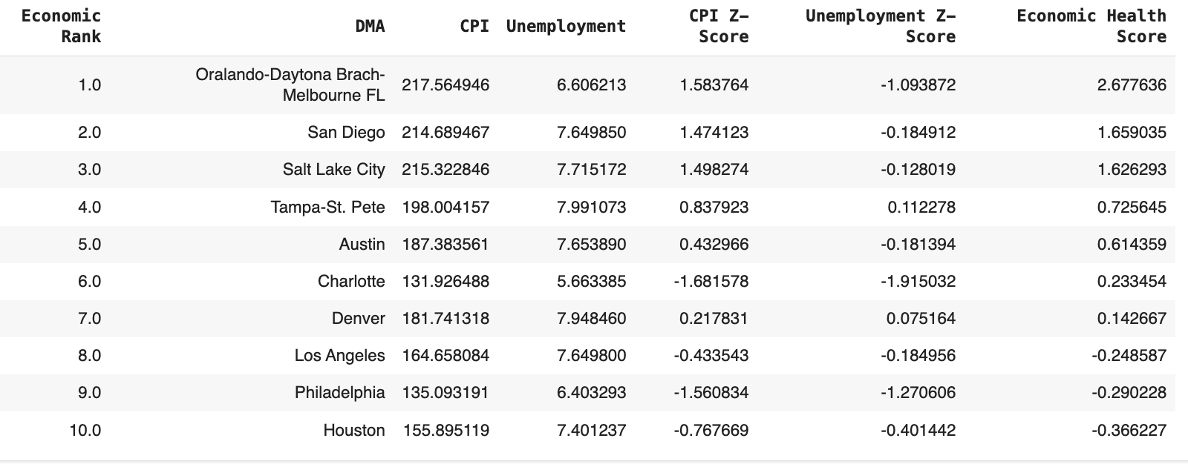

*Figure 8: Top 10 DMA Economic Health Scores*

The last factor analyzed was the economic health of the different DMAs. Figure 8 shows the top ten DMAs that have the highest economic score. To calculate the economic health score for the DMAs, the CPI and Unemployment values were z-scored which makes the two variables easier to compare to one another since they are both on different scales. CPI, or consumer price index, measures the average change over time in the prices paid by urban consumers, and unemployment represents the unemployment rate in the DMA. The economic health score is calculated by subtracting the z scored unemployment value from the z scored CPI value. The DMAs with the strongest economic health score were Orlando-Daytona Beach-Melbourne FL, San Diego, Salt Lake City, and Tampa-St. Pete. Los Angeles, Philadelphia, and Houston had negative economic health scores which indicates that they might be facing some economic challenges compared to the other DMAs.

After careful analysis of the different DMAs, the top ten markets that offer the most advantageous opportunities for Target Light to grow have been identified. Some of the DMAs that were close but did not make the cut were Kansas City, Salt Lake City, Atlanta and Dallas Ft-Worth. Kansas City has a low population, median household income, household count and very low holiday sales which makes it a less attractive DMA for Target Light. Atlanta and Dallas Ft-Worth both present higher competition with 4 stores each and some indicators that make them less favorable compared to the chosen DMAs. Salt Lake City was close but had factors like low population density and lower holiday sales that took it out of the running. The DMAs selected below are based on a combination of low competition, favorable economic conditions, and strong consumer spending indicators. Most of these DMAs also had more data within the datasets, which provided a clearer outlook on how Target Light would perform. Each selection has a summary including the reasons for their selection:

1. **Chicago** presents an appealing market for expansion boasting a very high population, the third largest household count, and a fairly high median household income, suggesting that the consumer has a good amount of spending power. Chicago also has the second lowest store per capita ratio, indicating a less saturated market and greater potential for new retail locations. Although the DMA does have a lower economic health, which might bring up some challenges, this could mean a lower cost of entry and reduced competition, positioning it as a key entry location. The large population and incredibly high numbers of households will lead to a sizable customer base, yielding high volumes of foot traffic and potential sales numbers.
2. **Los Angeles** has the second largest population and a moderate median household income. This combination offers a widespread market of potential customers who have a reasonable level of disposable income. The city also has moderately high average holiday sales, displaying the city’s ability to produce profit in peak seasons and suggesting targeted marketing during these times would be very beneficial. Los Angeles does have many competitor stores but the high average weekly sales show the consumers tend to spend.
3. **New York** stands out because it has the highest population of any city in the United States. The city also has the highest household count and a moderately high median household income. There was no data on how competitive stores performed in New York, but the sheer size of population and income numbers make it an attractive prospect. Some other DMAs with high populations like Philadelphia, Chicago, and Los Angeles produce solid sales numbers so we assume that New York would follow that same trend. New York is also known for being very busy during the holiday season, so we can expect lucrative sales numbers during those times for Target Light. New York’s density and diversity may require a specific customer service and company branding, but the potential financial payoff in this DMA is too great to pass up.
4. **Tampa-St. Pete** has a higher stores per capita value but makes up for it by recording the third highest average weekly sales, suggesting strong ongoing demand within the DMA. Tampa-St. Pete also has a positive economic health score reflecting a robust economy. Having the third highest average holiday sales indicates a strong seasonal market, which will also offset the saturation.
5. **Philadelphia** offers a unique opportunity for Target Light due to the high population and the lowest stores per capita ratio of the DMAs considered. The moderate median household income indicates that there is a large middle-class base that is ready to spend. For such a large city like Philadelphia it is very surprising to see it only has two competitor stores. Target Light has an opportunity to thrive in this DMA because of the less crowded market space. They also showed high average holiday sales revealing a seasonal increase in consumer spending that would be very beneficial.
6. **Orlando-Daytona Beach-Melbourne FL** presents a rare combination of high average weekly sales and the best economic health score among the DMAs. There are many consumers in this area that are financially secure and prepared to spend. With only one competitor store, the Florida market is ready for new businesses to create a dominant presence. Elevated holiday sales reveal a market that is well-suited for seasonal shopping by both tourists and local consumers.
7. **San Diego** is a market that contains considerable growth and financial stability because it has the second strongest economic health score. The combination of its high median household income and low store per capita ratio shows that there is an opportunity for consumer spending to surge. When Target Light enters this market, they can tap into a moderately sized population with disposable income and gain business from a vast number of tourists. These lifestyles will help the company keep consistent sales throughout the year and see increases during holiday and busy vacation seasons.
8. **Charlotte** is an attractive market because of its low amount of competition and strong economic health. The economy in this DMA is expanding and seems to be prospering locally. The moderate population size and stable market would allow Target Light to grow. With only two competitors and solid holiday sales numbers, Charlotte is a great market for Target Light to carve out a significant market share.
9. **Denver**’s market contains a low market saturation level and has a positive economic health score, which both indicate that this market is suitable for new entrants. They have a fairly high median household income, so the consumers do have spending power, and a decent sized population, meaning there is a sizable customer base ready to support new businesses. Denver does have low average holiday sales compared to other DMAs but there might be some opportunities to increase those sales during the seasonal times.
10. **Houston** is an interesting DMA because it has a negative economic health score but also the highest average weekly sales and the highest average holiday sales. These numbers suggest a consumer base that is engaged in shopping and loves to spend. Despite some economic concerns in this market, customers are still making large purchases. The high population and household count show that the market is substantial. There are four competitor stores in the area, but this is not as concerning because of the overall market size and consumer spending habits. Although there is some risk that comes with Houston due to the poor economic health, the market provides a great opportunity for financial success so Target Light would be wise to launch a location in this DMA.

In conclusion, the strategic market analysis performed for Target Light’s retail expansion has produced a variety of potential locations that each have their own unique set of advantages. The data driven approach conducted in this analysis compared existing competition, economic strength, and consumer spending habits within the different DMAs to one another. The recommendation plan revealed that the following locations would be best to launch this new startup company to compete against stores like Target and Walmart: Chicago, Los Angeles, New York, Tampa-St. Pete, Philadelphia, Orlando-Daytona Beach-Melbourne FL, San Diego, Charlotte, Denver, and Houston. This array of markets collectively offers Target Light robust opportunities to develop as a company and grow financially. The data we were given to work with provided enough evidence to why these specific locations will work best for the Target Light launch. Some other locations were considered but they either did not have as much potential as the selected markets or there was not enough data to make them a viable candidate. The chosen DMAs exhibit an exciting mixture of high consumer traffic potential, flourishing economies, and many of them having lower competition levels. As Target Light continues its journey, the insights derived from this report should pave the way for the initial store launches and act as a blueprint for future company expansion. By establishing its presence in these select locations, Target Light will secure a strong position in the competitive retail field, building a durable foundation for the company to grow alongside and compete with juggernauts like Walmart and Target.